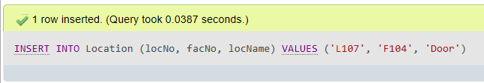

INSERT INTO Location (locNo, facNo, locName) VALUES ('L107', 'F104', 'Door');